

Title Page
Title: Marketing Management (MG-1002) Project
Case Study: Top Edge Technology – Consolidated Report

Submitted To:
Dr. Syed Shujaat Ali Shah
FAST School of Computing, Lahore

Submitted By: Group - 5
Muneeb ur Rehman - 23L-0511
Abdul Munam Aziz - 23L-3019
Hassan Mehmood - 23L-0818
Junaid Muhammad - 23L-1014
Ammar Noor Zia - 23L-0558
Section: 4A
Batch: BSCS – Spring 2025

Date of Submission:
17th April 2025

Project Summary / Abstract
Purpose of the Report:
This report examines the marketing strategies and operational challenges of Top Edge Technology, a Multan-based product-oriented IT firm specializing in mobile game development. It explores how the company generates revenue through digital marketing, ad-based monetization, and geo-pricing strategies, while also addressing key marketing-related challenges such as offline ad revenue loss and platform fragmentation due to region-specific store requirements.

Methodology / Approach
The analysis draws from:
- Secondary research including the company’s official website and industry sources
- Observations of product behavior and monetization models
- Application of marketing management concepts and software-based solutions aligned with global trends

Key Findings
- Top Edge effectively monetizes free-to-play games using region-specific ad pricing and strategic in-game ad placements
- Offline ad loss can be addressed through ad caching and reward queuing systems
- Modular build architectures and geo-configurable features reduce platform compliance overhead
- The company adopts a data-driven marketing strategy backed by real-time performance analysis
- Global scalability is challenged by regional constraints (e.g., Iran, Russia), but can be managed with localized, adaptive strategies

Main Headings for Report Body:
1. Introduction
- Overview of Top Edge Technology
- Business Model (Product-based)
- Key services and platforms
- Quote from their website (with citation)

2. Industry Review
- Global software and digital product industry
- Global mobile gaming industry
- Pakistan's IT and gaming market
- Supporting stats and citations

3. Products, Services & Brand Positioning
- General Services (app dev, e-commerce, software)
- Core vertical: Mobile gaming
- Monetization model: Ads, geo-pricing
- Game genres and revenue contribution
- Example: Games Arena, Circus Balls

4. Marketing Department / Functions
- Team structure and key members (Asad, Mughees, etc.)
- Department roles
- Marketing strategies (ads, localization, analytics)
- Tools used: Unity Ads, Facebook, in-house dashboards

5. Strategic Challenges & Solutions (This is where Deliverable 2 fits in)
5.1. Problem 1: Revenue Loss Due to Offline Usage
- Explain the challenge
- Software-based solutions (ad caching, reward queuing)
- Table showing solution → outcome
5.2. Problem 2: Platform Fragmentation & Regional Regulations
- Challenge: multiple stores, compliance policies
- Software solutions: modular builds, geo-configuration
- Table and/or flowchart showing architecture

6. Performance Growth & Forecast (Optional but Strong Section)
- Game download data (2022–2025)
- Strategic growth factors (ASO, advertising, product-market fit)
- Forecast method
- Game Development KPIs Table
- User Engagement by Genre (daily playtime stats)

7. Conclusion

8. References:

1. Introduction: Key Operations of Top Edge Technology:
Top Edge Technology is an emerging IT firm based in Multan, Pakistan. They are specialized in mobile game development, App development (in both Android and iOS), E-commerce and offer digital marketing solutions. They are a product-based company (focuses on designing, building and marketing its own digital products).
“We specialize in delivering cutting-edge innovations across various industries, focusing on developing a wide range of applications, games, and software tailored for diverse users. As a product-based company, we’re committed to creating solutions that make a real impact.” (Top Edge Technology, 2025).
Top Edge Technologies offers a wide range of digital services including:
App Development:
Custom apps for Android and iOS apps, developed to meet client requirements in business, education, entertainment and many other services.
Game Development:
Popular for creating interesting and games that are well defined with present day technologies and tools used to develop these games.
Software Development:
Developing responsive websites and web applications using latest frameworks.
Digital Marketing:
Offers services (Search Engine Optimization) SEO, social media management, content marketing and ad campaign services.
They also offer Ecommerce Solutions. Top Edge Technology has successfully launched several mobile applications mostly mobile games available on Android and iOS platforms. While rooted in Multan, Top Edge Technologies has extended its services to a global level.
We will be talking about one of their fundamental operations that revolves around earning revenue from ad by strategically designing game experiences meaning to perform to marketing through ads using there gaming or any other app platform. The company also uses detailed analysis to track user behavior like engagement of user with ad in order to redefine their approach.
2. Industry Review:
Top Edge Technology is a part of the larger software and digital products sector or industry, which also encompasses businesses that create applications, games, platforms and provides user end services. This industry has experienced rapid growth over the past twenty years due to more digital transformation and smartphones that is owned by almost every person at present. (Deepseek – R4 prompt)
In Pakistan, the IT industry has expanded at a fast rate, with software exports reaching to over $2.6 billion in 2023 (Statista, 2024). Several Pakistani firms, including Top Edge Technology, have made the transition from providing client-based services to creating their own digital offerings, which enable scalability, greater profit margins, and market penetration worldwide.
In the software sector, Top Edge Technology has made its place in the mobile gaming market which we are discussing in this report, one of the most rapidly growing segments of the world.
Discussing the global market, according to Wikipedia:
“As of July 2018, video games generated US$134.9 billion annually in global sales. In the US, the industry earned about $9.5 billion in 2007, $11.7 billion in 2008, and US$25.1 billion in 2010.The global games and services market is forecast to shrink 1.2% annually to $188 billion in 2022.” (Wikipedia – Video Game Industry)
Considering its future potential, according to precedence research,
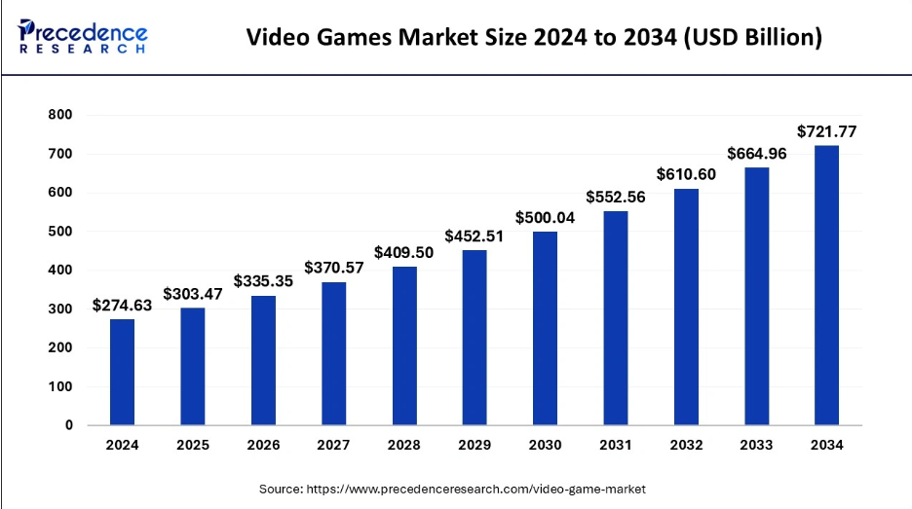
Discussing Pakistan alone, according to Statista, IT Services market in Pakistan is expected to reach US$2.63bn. and is projected to have a market volume of US$903.67m in 2025(Statista, 2024). Pakistan’s mobile gaming market is also growing, due to low-cost smartphones, cheaper mobile internet, and a large number of youth population.

Top Edge develops casual games which are:
- Designed for short, repeatable sessions
- Optimized for ad-supported monetization
Challenges in the Mobile Gaming Industry:
The mobile gaming industry, although is growing rapidly and at a very swift pace, it is still expected to face many challenges that impact both well-established game developers and newer firms like Top Edge Technology.
1. User Retention
After downloading retaining players or users is a great challenge. A large number of users quit the game after a very few numbers of plays that reduces the ad exposure and the revenue generated using those ads. By performing analysis, developers can find the point where user feels frustration, track places or points of frustration and improve game design to keep players engaged.
2. Ad Fatigue and User Experience
Mobile games usually use in-app ads to earn revenue. Nonetheless, too many or inappropriate ads can irritate users, causing negative reviews and uninstalls. The balance between monetization and user experience is a fragile one. Top Edge Technology for instance places ads strategically where users have to interact with them in order to move on but the strategy has to be watched out for lest it creates user annoyance.
3. Dependence on the internet:
Most games that rely on ads need a stable internet connection to serve ads and make money. This is a huge problem in areas where users lack or have poor internet connectivity. For instance, if a user downloads a game and plays offline, no ads are served meaning zero revenue from each session.
4. Fragmentations of Platforms:
With the emergence of alternative app stores like Samsung store, Huawei App etc. game developers now need to publish and maintain their games on multiple platforms. Each platform comes with its own technical requirements and store policies which increase complexity and cost in the development and marketing process.
5. Regional Regulations and Compliance
Every country has a unique or specific legal and technical requirements for mobile apps and games. For instance, launching a game in a country like China it involves extreme censorship and localization of apps meaning to involve a local company. Similarly, there are privacy laws in many countries so adding an extra cost for game developers.

3. Products/Services by the Organization
Top Edge Technology has strategically positioned itself within Pakistan’s fast-evolving digital product development ecosystem. Leveraging a product-based business model, the company minimizes dependence on third-party clients by managing the full life cycle of digital products—from idealization and development to monetization and distribution. This approach allows Top Edge Technology to control quality, scalability, and brand identity across its offerings.
A. General Services Portfolio
Operating within the Information and Communication Technology (ICT) domain, Top Edge Technology offers a robust portfolio of digital solutions designed to serve multiple verticals. These include:
- App Development: Native and cross-platform mobile applications tailored for sectors such as education, healthcare, retail, and entertainment. The focus is on intuitive UI/UX design, user engagement, and market-specific functionality.
- Software Development: Agile, saleable, and secure web and desktop solutions built using modern tech stacks such as React.js, Node.js, and Laravel, catering to both B2B and B2C markets.
- E-commerce Solutions: Fully managed online stores with built-in payment gateways, order tracking, and logistics integration. Emphasis is placed on conversion rate optimization (CRO) and mobile-first interfaces.
- Digital Marketing: End-to-end services that include search engine optimization (SEO), content marketing, social media growth, paid media, and influencer outreach aimed at enhancing digital visibility and customer acquisition.
These foundational services reinforce the company’s market presence and lay the groundwork for its core vertical—digital entertainment.

Say for example: -> Games Arena is an innovation by top edge technology
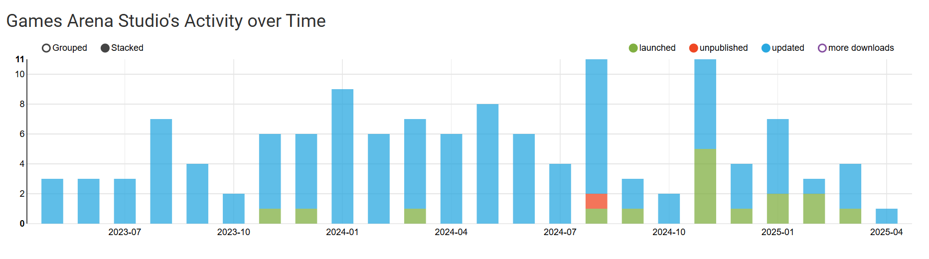
And it’s one the leading game (Circus balls) stats over the past few months:
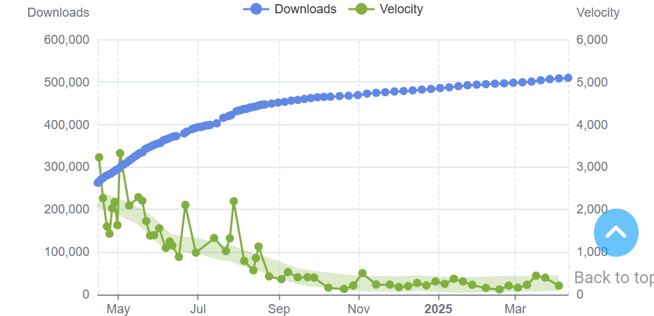
With over 500K users globally

B. Brand Focus – Digital Entertainment & Mobile Games
Top Edge Technology’s brand is most strongly associated with its offerings in the digital entertainment industry, particularly mobile game development. While secondary products such as in-game advertising solutions and limited-edition merchandise drops complement its ecosystem, the company’s core value proposition lies in its diverse and culturally resonant catalog of mobile games.
With a brand promise built on accessibility, innovation, and localized content, the organization markets itself as a one-stop platform for immersive and casual gaming experiences. These games are globally accessible via Android and iOS devices and are designed with:
- Premium monetization models: Core gameplay is free, with monetization achieved through rewarded ads, interstitial placements, and offer walls.
- Cultural customization: Games incorporate region-specific aesthetics and narratives, enhancing resonance with local audiences in Pakistan and emerging markets.
- Gamified UX/UI: Focused on short, addictive play sessions and smooth user on boarding, which increases session duration and retention.
By aligning product development with behavioral analytic, the company consistently refines user experiences to increase LTV (Lifetime Value) and ARPU (Average Revenue Per User).

1. Revenue Contribution by Game Genres
The company’s financial strength stems largely from its varied game genres. Among these, action games hold the largest share (30%) of the total revenue, followed by puzzle games at 25%, multiplayer formats at 20%, and RPGs at 15%.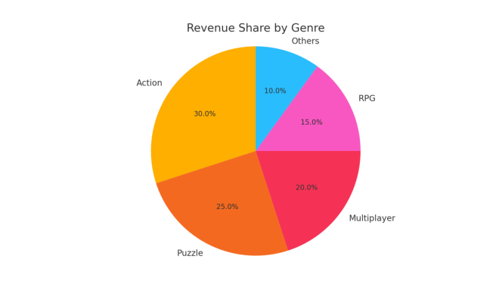

4. Marketing Department / Function
Top Edge Technology’s marketing team is a high energy, cross-functional team that closely collaborates with the development and analytics teams. The team is organized to concentrate on user acquisition, product visibility, monetization, and regional adaptation, ensuring that marketing aligns with the overall product lifecycle, particularly for mobile games.
The marketing department functions under the guidance of Asad Bashir (Team Lead - Marketing Operations), who oversees strategy implementation, campaign planning, and global reach. Mughees ul Hassan (Marketing Executive) plays a key role in coordinating digital ad campaigns, tracking performance, and optimizing content for different markets.
Department Structure and Key Roles
- Asad Bashir – Team Lead, Marketing Operations
Manages overall campaign strategy, budgeting, geo-pricing, and cross-team coordination.
- Mughees ul Hassan – Marketing Executive
Handles digital campaigns, ad placements, in-app promotion strategies, and campaign reporting.
- Fahad Safeer– Performance Analyst
Tracks KPIs such as CPM, CTR, and retention. Works with data dashboards to interpret user behavior.
- Rehan Hameed – Creative Content Designer
Designs game banners, ad creatives, and store visuals aligned with brand identity and user trends.
- Aoun Abbas– User Acquisition Specialist
Manages paid ads through platforms like Unity Ads and Google Ads, targeting high-ROI audiences.
- Zaid Abid – Localization and Compliance Coordinator
Ensures regional legal, linguistic, and cultural adaptations of games and marketing materials.
Problem Area and Solutions
Introduction to the Problem:
Being a product oriented mobile game development firm, Top Edge Technology depends significantly on in-game ads as a source of revenue generation. This model is only effective in connected settings, it becomes a critical circumstance where users play offline. Moreover, the increasing diversity of mobile app stores and regional compliance regulations has significantly impacted the company’s ability to efficiently market and distribute its products.
These problems have direct effect on the company’s marketing reach, operational expense, and overall revenue potential. To remain competitive, particular in an oversaturated mobile gaming market, the company must need to address these problems using intelligent, scalable and software-based strategies.

Background and Analysis:
Problem 1: Loss of Revenue Due to Offline Usage
Top Edge’s main revenue source is displaying ads while the player is playing that specific game. Although, when the player downloads the game and shut the internet connectivity intentionally or due to numerous limitations, no ads are served, resulting in zero revenue from such sessions. This is a major deficit, particularly considering that many users in South Asian and Middle Eastern regions have limited or unstable internet connectivity.
Without internet, the marketing strategy (ads for revenue) fails, and the user proceeds without contributing to the company’s earnings. This problem is particularly noticeable in casual games, where frequent sessions are expected, but not every session guarantees connectivity.
Problem 2: Platform Fragmentation and Regional Policy Compliance
Top Edge now has to manage and publish games on multiple app stores such as:
- Google Play Store
- Apple App Store
- Samsung Galaxy Store
- Huawei AppGallery
Each store has different technical requirements, review processes, and localization demands. Furthermore, countries like China, Iran, and Russia have unique digital policies that force the company to alter its game content or block features altogether. These additional efforts place a financial and technical burden on the marketing and development teams.

Software-Based Solutions:
Solution to Problem 1: Offline Ad Support System
To address the problem of lost revenue from offline play, Top Edge can adopt the following software-based features:
- Downloadable Ad Packs: Ads (video or interactive) can be preloaded during the first game session or whenever the internet is available. These cached ads are then served during offline gameplay at key checkpoints.
- Reward Queuing Mechanism: When players perform reward-triggering actions offline (like completing a level), the game stores the action and automatically prompts the player to watch an ad when the internet is reconnected. This ensures monetization is only delayed — not lost.
- Smart Ad Placeholder Logic: In critical game sections, placeholder screens encourage the user to reconnect for bonus content or in-game advantages, creating a loop back to ad exposure.
Impact:
- Reduces revenue loss from offline users
- Increases total ad impressions and user engagement
- Enhances user experience by offering smoother reward cycles

Solution to Problem 2: Modular Build Architecture
To minimize cost and effort associated with platform-specific and region-specific distribution, the following approaches can be implemented:
- Modular Game Design: Core gameplay remains the same across versions, while platform-specific features (e.g., payment methods, login APIs, visual compliance) are plugged in through separate modules.
- Automated Build Tool: Develop an internal tool that allows the team to auto-generate builds for different app stores with just a few toggles — handling asset inclusion, ad network SDKs, and store metadata.
- Geo-Configurable Game Settings: The game can detect the user’s region and adjust content, ads, and language accordingly. For example, it can disable in-app purchases in countries with currency or legal issues and adjust ad networks based on region availability.
Impact:
- Saves development and marketing time
- Ensures compliance without building from scratch
- Expands global reach without excessive manual work

Table: Summary of Problems, Solutions, and Outcomes
Problem | Software Solution | Expected Outcome
Offline Play = No Ads = No Revenue | Ad Caching + Reward Queuing | Increased revenue from offline users
Multi-Store Requirements | Automated Build Tool + Modular Design | Reduced dev time and cost
Regional Policy Differences | Geo-Configurable Features | Improved compliance and user experience

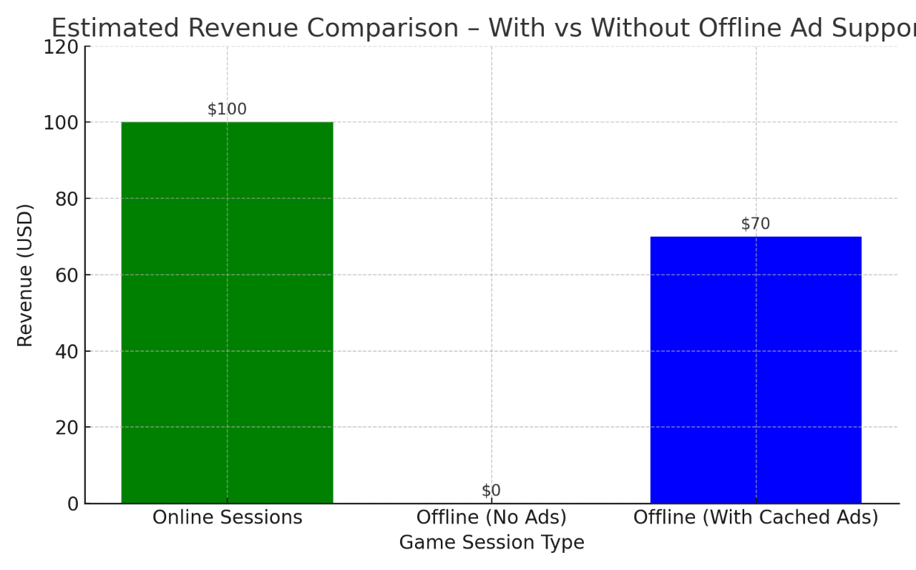

Current status and future analysis of products
Game Download Growth (2022–2025)
Top Edge Technology has experienced an impressive and sustained growth trajectory in mobile game downloads, reflecting its expanding brand equity and effective market penetration strategy. From 5 million downloads in 2022,9 million in 2023, the company achieved 13 million downloads in 2024(Games Arena Studio - Android developer info on AppBrain), marking a remarkable 160% growth. This surge underscores both the rising popularity of its mobile gaming portfolio and the increasing user satisfaction with its offerings.
Strategic Insights Behind the Growth:
Several critical factors have contributed to this expansion:
- Product-Market Fit: A well-calibrated alignment with the needs and preferences of mobile gamer, ensuring high user satisfaction and retention.
- User Acquisition Funnels: High-performing acquisition strategies, leveraging targeted advertising campaigns and real-time performance tracking.
- App Store Optimization (ASO): Enhanced ASO practices across major platforms to ensure visibility and discoverability.
Advertising: Leveraging social media platforms and targeted ads to reach mobile-first regions, especially South Asia and MENA, where mobile usage is rapidly growing.
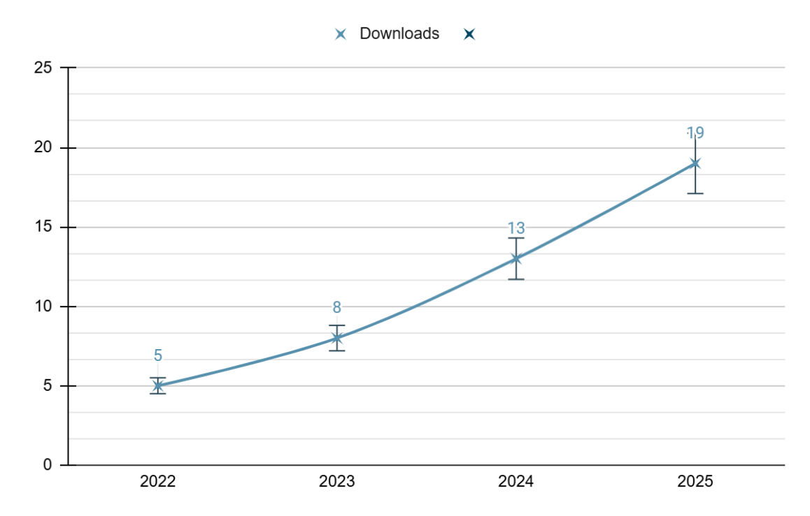
The prediction 2025 is made using Facebook Prophet website
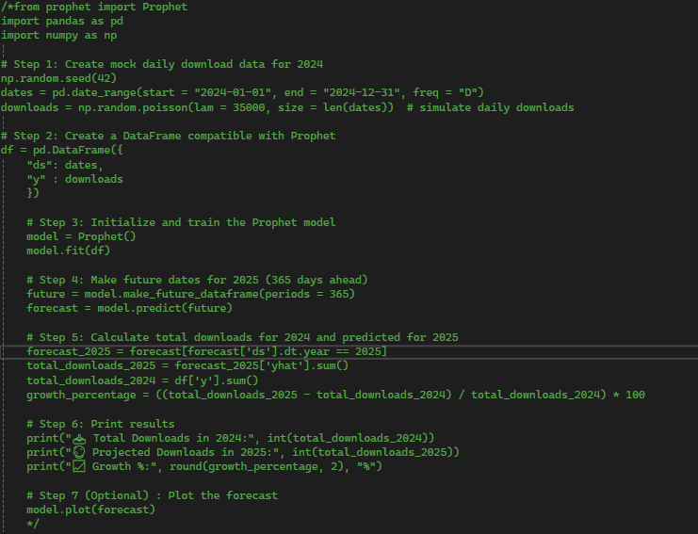
How It Works:
Raw Data Input:
It defines key metrics like downloads, active users, session time, revenue per user, and retention.
DataFrame Creation:
Uses pandas to create a neat table (DataFrame) from the dictionary.
Growth Calculation:
It computes the percentage growth from 2024 to 2025 for each metric.
Column Arrangement:
Orders the columns for easy reading: Metric → 2024 → 2025 → Growth → Insights.
Print Table:
Outputs the final table as a readable report (no index numbers).
2025 Strategic Focus:
In 2025, Top Edge Technology is poised for further growth with the release of six new casual mobile titles. These games are designed with a strong focus on retention and monetization optimization, incorporating:
- Gamified User Experience (UX): Engaging game mechanics that boost user involvement.
- Behavioral Analytics: Tracking user actions to personalize in-game experiences.
- Hybrid Monetization Models: Including rewarded video ads, interstitial, and offer walls, ensuring monetization without compromising the user experience.
Game Development KPIs (2024–2025)
The following table outlines Top Edge Technology’s year-on-year growth in core performance indicators for its mobile games:
Metric | 2024 | 2025 (Projection) | Growth (%) | Marketing Insight | Engagement Impact
Total Game Downloads | 13 million | 19 million | +46% | Brand Reach Expansion | User Acquisition
Daily Active Users (DAU) | 350,000 | 540,000 | +54% | Retention Campaigns | Community Building
Avg. Session Duration | 4.3 min | 6.1 min | +42% | UI/UX Upgrades | Session Stickiness
ARPU (Ad Revenue/User) | $0.23 | $0.37 | +60% | Ad Monetization Strategy | Revenue Scaling
Retention Rate (Day 7) | 18% | 27% | +50% | Gamification Mechanics | Loyalty Growth
Using Python library Pandas this raw data was formatted:
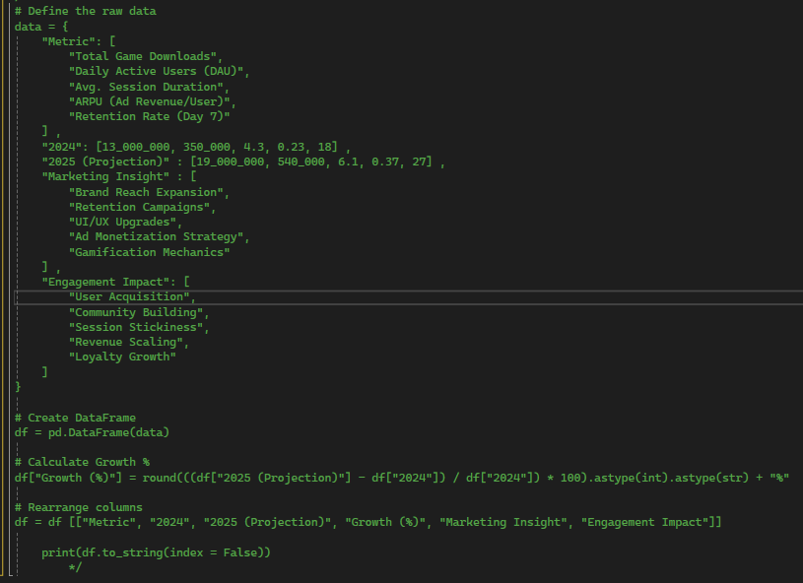
How It Works
Generate Mock Data
Simulates daily downloads in 2024 using random numbers.
Train Prophet Model
Prophet (a forecasting tool by Facebook) learns from this daily data.
Make Future Forecast
It predicts downloads for each day in 2025.
Summarize
It adds up all downloads from 2024 and predicted 2025, and calculates growth %.
Export to CSV
Saves the results in a file like Excel.
Key Insights from the Metrics:
- Game Downloads: The 46% increase in downloads from 13 million in 2024 to 19 million in 2025 highlights continued growth, driven by both new titles and expanding market reach.
- Daily Active Users (DAU): A 54% increase in DAU indicates successful user acquisition and retention strategies, especially through targeted marketing and community-building efforts.
- Session Duration: The 42% growth in average session duration from 4.3 minutes to 6.1 minutes reflects successful UI/UX upgrades, making the games more engaging and "sticky" for users.
- ARPU: A 60% increase in Ad Revenue per User (ARPU) is a clear result of the effective ad monetization strategies, indicating that the company is successfully scaling revenue without sacrificing the user experience.
- Retention Rate (Day 7): The 50% growth in Day 7 retention demonstrates the effectiveness of gamification mechanics and in-game rewards, contributing to increased loyalty and user engagement over time.
3. User Engagement by Game Type
Daily playtime is a critical performance indicator for both user retention and monetization efficiency. Among Top Edge Technology’s portfolio, multiplayer games consistently outperform other genres, boasting an average daily playtime of 60 minutes, followed by role-playing games (RPGs) at 50 minutes, and action games at 40 minutes. This hierarchy of engagement underscores the impact of social connectivity, narrative depth, and interactive mechanics on user immersion.
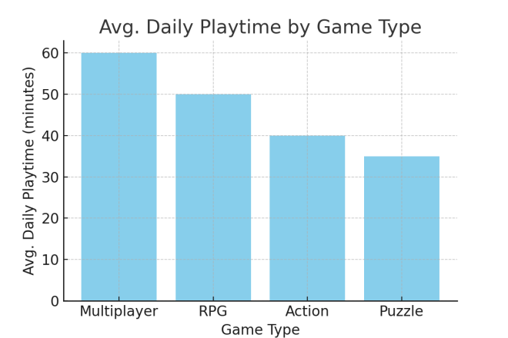
Conclusion:
Top Edge Technology has established itself as a competitive product-based IT firm by combining creative marketing with strong technical foundations. While challenges like offline ad loss and platform fragmentation affect revenue and growth, the company effectively tackles them using software-driven solutions such as ad caching and modular app design.
With a marketing strategy rooted in data, user behavior, and regional adaptation, Top Edge continues to evolve in the fast-paced mobile gaming industry. Its integrated approach highlights how technology and marketing can work hand-in-hand to drive sustainable success.

Reference List
Bunting, D. (2024). 6 Gaming Analytics Challenges and How to Solve Them. [online] ChaosSearch. Available at: https://www.chaossearch.io/blog/solving-gaming-analytics-challenges [Accessed 14 Apr. 2025].
Deloitte. (2023). Global Mobile Game Industry Outlook. [online] Available at: https://www2.deloitte.com/insights/us/en/industry/technology/mobile-gaming-trends.html [Accessed 13 Apr. 2025].
Newzoo. (2023). Global Games Market Report. [online] Available at: https://www.newzoo.com/insights/trend-reports/global-games-market-report [Accessed 13 Apr. 2025].
Precedence Research. (2024). Video Game Market Size and Forecast. [online] Available at: https://www.precedenceresearch.com/video-game-market [Accessed 13 Apr. 2025].
Statista. (2024a). IT Services - Pakistan. [online] Available at: https://www.statista.com/outlook/tmo/it-services/pakistan [Accessed 13 Apr. 2025].
Statista. (2024b). Mobile Games - Worldwide. [online] Available at: https://www.statista.com/outlook/amo/media/games/mobile-games/worldwide [Accessed 13 Apr. 2025].
Top Edge Technology. (2025). About Us. [online] Available at: https://topedge.pk/about [Accessed 13 Apr. 2025].
Unity Ads. (2023). How to Monetize Games with Ads. [online] Available at: https://unity.com/solutions/unity-ads [Accessed 13 Apr. 2025].
Department Information through Linkedin..
Ali, S.A. (2025). LinkedIn Profile. [online] Available at: https://www.linkedin.com/in/sardar-anser-ali-5331611a/ [Accessed 13 Apr. 2025].
Safeer, F. (2025). LinkedIn Profile. [online] Available at: https://www.linkedin.com/in/fahad-safeer-1b3243243/ [Accessed 13 Apr. 2025].
Hameed, R. (2025). LinkedIn Profile. [online] Available at: https://www.linkedin.com/in/rehan-hameed-002405254/ [Accessed 13 Apr. 2025].
Abid, Z. (2025). LinkedIn Profile. [online] Available at: https://www.linkedin.com/in/zaid-abid-525559233/ [Accessed 13 Apr. 2025].
Hassan, M.U. (2025). LinkedIn Profile. [online] Available at: https://www.linkedin.com/in/mughees-ul-hassan-4b56b41b2/ [Accessed 13 Apr. 2025].
Abbas, A. (2025). LinkedIn Profile. [online] Available at: https://www.linkedin.com/in/aaoownabbas/ [Accessed 13 Apr. 2025].
Bashir, A. (2025). LinkedIn Profile. [online] Available at: https://www.linkedin.com/in/asad-bashir-b90262120/ [Accessed 13 Apr. 2025].

